Dramatic Structure/ Plot

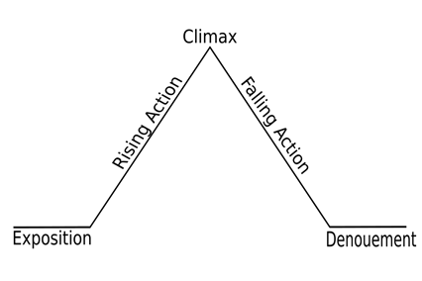

Exposition
Introduces the main characters of the story, shows how they relate to one another, their goals and motivations, and their moral character. The protagonist gets to know their main goal and what is at stake.

Rising Action
In this phase, the protagonist understands his or her goal and begins to work toward it. Smaller problems thwart their success. This phase demonstrates how the protagonist overcomes these obstacles. Dramatic tension builds.

Climax
The turning point or highest point of the story. The protagonist makes the single big decision that defines not only the outcome of the story, but also who they are as a person. It often contains much of the action in a story—for example, a defining battle.

Falling Action
This phase consists of events that lead, in most cases, to the ending of the story. Characters’ actions resolve the problem.

Resolution
Also called the “Denouement”, the protagonist and antagonist have solved their problems and the conflict officially ends. Some stories shows what happens to the characters after the conflict/ what happens to the characters in the future.

